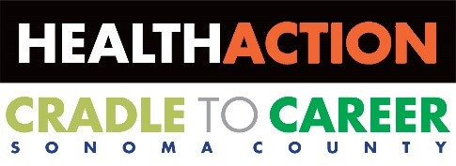
Cradle to Career Operations Team Meeting
Agenda
September 18, 2019
8:30 a.m. – 10:00 a.m.
North Coast Builders Exchange, 1030 Apollo Way, Santa Rosa
The Board of Directors Room

- Welcome and Check-in
Time: 8:30-8:40 a.m.
Presenter: Kathy Goodacre
Action Item: Approve agenda
Action Item: Approve August Minutes

- Announcements & Updates
Time: 8:40-9:30 a.m.
Presenters: Kathy Goodacre, Dan Blake. Angie Dillon-Shore, Kellie Noe, Lisa Carreño
- Membership
Action Item: Vote on Cradle to Career Membership
- Portrait of a Graduate Implementation
- Advocacy Update
- Performance Measures and Dashboard Update
- Our Kids Our Future Update
- Equity in Education Initiative Update

- Supporting Cradle to Career Goals
Time: 9:30-9:55 a.m.
Presenters: Kathy Goodacre, Angie Dillon-Shore
- Legislative Update
- Ways to educate, connect & amplify: Cradle to Career members share opportunities

- Conclusion and Check-out
Time: 9:55-10:00 a.m.
Presenter: Kathy Goodacre
Public Comment
Future Agenda Items
Next Meeting Date and Time: October 24, 2019
8:30-10:00am
Adjourn

Times are approximate.
Presenters are subject to change.

For more information, contact Alea Tantarelli, Department of Health Services, Cradle to Career Initiative (707) 565‐5364, Alea.Tantarelli@sonoma-county.org.

Note: Meetings are open to the public. Persons wishing to address Health Action are invited to speak during the Public Comment period. For information on access for persons with disabilities or to review materials, contact Department of Health Services, 1450 Neotomas Ave. Avenue, Suite 200, Santa Rosa, CA 95405, (707) 565-4700.

For your calendar:
Cradle to Career Operations Team: October 24, 2019 (8:30 a.m.-10:00 a.m.)
Health Action Leadership Team: October 24, 2019 (2:30 p.m. – 4:00 p.m.)
Health Action Council: October 4, 2019 (7:30 a.m. – 10:00 a.m.)

